UPS: A Risk Analysis



Michele Calderon, Logan Clay, Nicholas Coombes,

Jordan Fisher, Charles Kindt, Constance McConnon

**Table of Contents**

Project Link 3

Executive Summary 3

Background Information of the Organization 3

Mission of UPS (in terms of multiple success criteria) 4

Essential Business Functions 4

Stakeholder Analysis 5

Project Scope Statement 5

Assets 6

Potential Security Incidents/Accidents 6

Risk Analysis 7

Bow-Tie Models 7

Risk Influencing Factors 8

Qualitative to Quantitative/Semi-Quantitative Risk Analysis 9

Data Dossier 9

Accident Scenarios 10

Causal and Frequency Analysis 10

Barrier Analysis 10

Cause-Consequence Analysis 11

References 13

# Project Link

Github Link: <https://github.com/ncoombes95/SRA-311-Project>

# Executive Summary

The United Parcel Service, or UPS, is the global leader in package shipping and delivery and supply chain management. In 2019, UPS delivered 5.5 billion packages and documents globally. As in-store retail purchases by consumers decrease and remote work for businesses increase, the importance of functionality in daily operations will be vitally important to UPS. Our risk analysis will highlight the unique challenges associated with UPS in its delivery and supply chain management for businesses and the public. The SHEL Model below outlines the relationships of major assets.

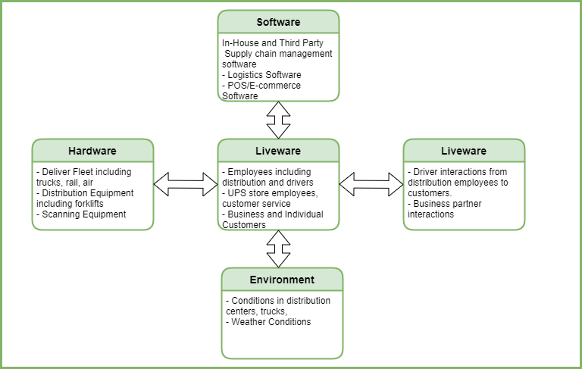

For our risk analysis, we will be using the National Institute of Standards and Technology (NIST) Guide for Conducting Risk Assessments (Special Publication 800-30). This methodology will allow us to organize threats and vulnerabilities through the NIST’s four step process for risk assessment of framing, assessing, responding, and monitoring risks.

By completing this assessment, we will be able to highlight specific areas of focus that are essential to their successful delivery of 2.19 million packages and documents daily, protection of customer information, and the safety of its employees, specifically drivers. While some risks like driver safety may be small in scale and monetary value, the reputation of UPS rests in all business functions working together and on-time for customer satisfaction. With revenue of $74 billion in 2019, UPS should be able to spare no expense to manage any major or minor risk.

# Background Information of the Organization

Established in 1907, UPS is a global courier and logistics company with its headquarters in Atlanta, GA. UPS’s CEO Carol Tome presides over 13 members in its Board of Directors which includes AT&T’s CEO John T. Stankey, former Heinz CEO William R. Johnson, and CVS’s CFO Eva Boratto. UPS employs 528,000 employees globally, with more than 1,800 operating facilities and 125,000 cars, vans, etc in its packaging delivery fleet. In addition to its delivery fleet, UPS also has over 500 jets. It provides customer access in over 220 countries and territories through its website ups.com, 5,200 retail stores, approximately 9,200 partnerships with authorized outlets, more than 37,000 UPS Drop Boxes, etc. UPS also offers supply chain management and operates UPS Freight through vehicles and trailers with 200 service centers across the U.S.

## Mission of UPS (in terms of multiple success criteria)

* Distribution of packages for business and consumer customers in a safe and timely manner.
* Solutions in shipping for business and consumer customers that is convenient.
* Operation of supply chain management through logistics and distribution for speed of service.
* Innovation in supply chain management, logistics, and business solutions with a focus on data analytics and market insight.

## Essential Business Functions

* Information systems for supply chain management and logistics
* Pick-up and delivery of parcels and documents with signatures where required
* Maintenance of fleet including vehicles, trucks, motorcycles, jets, tractor trailers
* Customer satisfaction that packages and documents arrive on time and in good condition
* Operations at warehouses including using heavy machinery
* Research and development of new technology for shipping and receiving

Our assessment will focus on information security, pick-up and delivery, and fleet maintenance.

Information for a request can be generated through multiple outlets. When a request is started a tracking number and shipping label will be created. Once the information is storage in a database on a secure server, it can be accessed by facilities, drivers, and customers. Logistical routes will be created and once the transaction is complete, the server is updated.

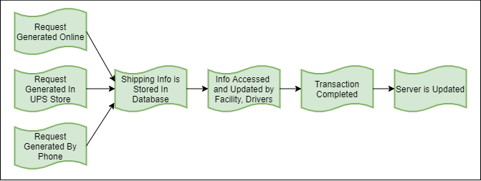

In shipping and delivery, a request is made that generates a tracking number and label. The facility that receives this information will then dispatch a driver for pick-up. The package can then move on to facilities across the world depending on its destination. The receiving facility will then send the package out for delivery. Once the package is delivered the transaction is complete.

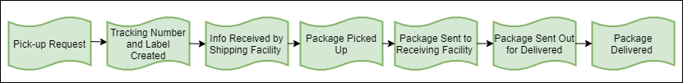

Maintenance of the delivery fleet is especially important to ensure packages are delivered on time for customer satisfaction. Preventative maintenance could be required depending on amount of use or season. Maintenance could be required if mechanical issues occur. A vehicle would be made unavailable while it is in for maintenance. Once maintenance is complete, the vehicle would be made available again for pick-ups and deliveries.

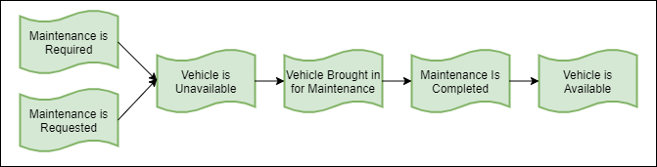

# Stakeholder Analysis

|  |  |  |  |  |
| --- | --- | --- | --- | --- |
| **Major Stakeholders** | **Urgency** | **Legitimacy** | **Capacity** | **Importance** |
| **Definitive- CEO, Board Members** | **X** | **X** | **X** | **4** |
| **Dominant- Governments (Domestic and International)** |  | **X** | **X** | **2** |
| **Dangerous- Disgruntled Employees, Hackers, Robbers** | **X** |  | **X** | **3** |
| **Dependent- Customers** | **X** | **X** |  | **3** |

By understanding the stakeholders and their levels of importance, we can see who will be affected most by risks and solutions we will propose. Additionally, we can better assess what specific risks will have the greatest impact on the business functions of UPS with consideration of these stakeholders and who has the power or perceived power to influence. For instance, if we find a high frequency of vehicle maintenance or accidents involving drivers, we will be able to offer solutions to reduce those risks which will decrease lawsuits and the number of affected employees. Mitigating risk of loss of tracking information will impact customer satisfaction. The information provided by this assessment will impact definitive stakeholders in terms of profit.

# Project Scope Statement

We will focus on are information security, shipping/delivery, and fleet maintenance. The reasoning for this is that the project will be focusing on the importance and efficiency of UPS’s ability to deliver packages safely and efficiently to its customers. Without these three business functions, UPS’s main form of economic stability would faulter and potentially grind to a halt, crippling the company. This, in comparison with UPS’s other divisions, would be deemed as their most important. UPS started small but eventually grew to its current size to be the global leader in package delivery and logistics. The only way for its reputation to be upheld is by its ability to coordinate shipping and delivery of billions of packages by ensuring their systems are secure, shipping and delivery is timely, and vehicles are functioning properly.

## Assets

|  |  |
| --- | --- |
| **Information Security** | |
| **Data** | Customer Records, Shipment Information |
| **Software** | Databases, Tracking Systems |
| **Hardware** | Computers/Laptops/Tablets, Servers, Routers |
| **Employees** | Information Security Personnel |
| **Machinery** | See Hardware |
| **Facilities** | Data Centers, Warehouses, Retail Stores |
|  |  |
| **Shipping & Delivery** | |
| **Data** | Customer Records, Shipment Information |
| **Software** | Databases, Tracking Systems, GPS |
| **Hardware** | Printers, Scanners, Satellites |
| **Employees** | Warehouse, Delivery Drivers |
| **Machinery** | Forklifts, Delivery Vehicles |
| **Facilities** | Warehouses |
|  |  |
| **Fleet Maintenance** | |
| **Data** | Service Records |
| **Software** | Maintenance Software, Diagnostic Tools |
| **Hardware** | Tools, Parts |
| **Employees** | Mechanics, Service Writers |
| **Machinery** | Equipment e.g. vehicle lifts |
| **Facilities** | Warehouses |

## Potential Security Incidents/Accidents

For a company as large as UPS, there are many potential security incidents or accidents that could impact their business functions. For each business function there are a few listed below. We have used Rasmussen’s Accident Categories to highlight the differences between security incidents or accidents that have high frequency and low consequence (Category 1), occur less often but have serious consequences (Category 2), or occur seldomly but can have catastrophic consequences.

|  |  |  |
| --- | --- | --- |
| **Information Security** | | |
| **Security Incident/Accident** | **Category** | **Covered in Analysis** |
| Data Breach | 2 | Yes |
| Power Outage | 2 | No |
| Hardware Failure | 2 | No |
|  |  |  |
| **Shipping and Delivery** | | |
| **Security Incident/Accident** | **Category** | **Covered in Analysis** |
| Delivery Vehicle Accident | 1 | Yes |
| Logistics System Failure | 2 | No |
| Package Lost, Stolen, or Damaged | 1 | Yes |
| Warehouse Fire | 2 | No |
|  |  |  |
| **Fleet Maintenance** | | |
| **Security Incident/Accident** | **Category** | **Covered in Analysis** |
| Vehicle Damaged During Repair | 1 | No |
| Incorrect Service Records | 2 | Yes |
| Natural Disaster | 3 | No |

# Risk Analysis

This risk analysis will include both qualitative and quantitative/semiquantitative analysis to show a comprehensive overview of the consequences of hazardous events on the business functions listed above.

## Bow-Tie Models

**Information Security**

Hazards: Human Error, Electrical Issues, Cyber Threats, Hardware & Software Controls

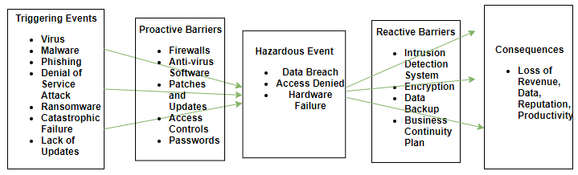

**Shipping & Delivery**

Hazards: Poor Safety Culture, Stress, Storms, Explosion, Theft, Cyber Threat

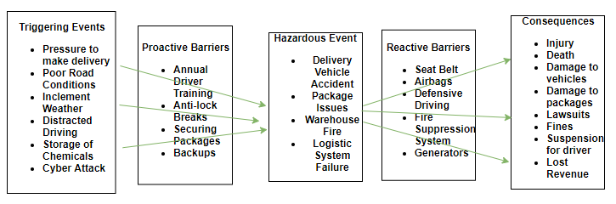

**Fleet Maintenance**

Hazards: Poor Maintenance, Poor Safety Culture, Human Error, Natural Disasters, Storms

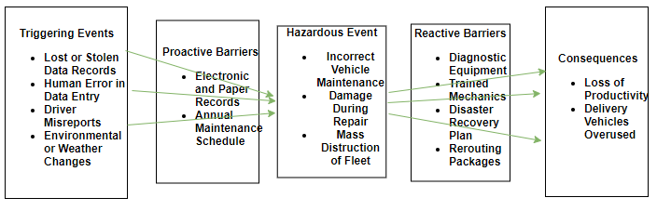

## Risk Influencing Factors

|  |  |
| --- | --- |
| **Information Security** | |
| **Operational RIF** | Operational Procedures, Controls, Routine Maintenance |
| **Organization RIF** | Cyber Security Culture |
| **Regulatory/Customer RIF** | Protection of Customer Information, Proprietary Info |

|  |  |
| --- | --- |
| **Shipping & Delivery** | |
| **Operational RIF** | Driver Training, Safety Features in Vehicle |
| **Organization RIF** | Health & Safety Culture, Teamsters Union |
| **Regulatory/Customer RIF** | Federal Motor Carrier Safety Administration, OSHA, Customer Satisfaction |

|  |  |
| --- | --- |
| **Fleet Maintenance** | |
| **Operational RIF** | Automatic Scheduling, Reporting Vehicle Issues |
| **Organization RIF** | Health & Safety Culture, Teamsters Union |
| **Regulatory/Customer RIF** | Federal Motor Carrier Safety Administration, OSHA |

## Qualitative to Quantitative/Semi-Quantitative Risk Analysis

Based on our understanding of the mission of UPS, business functions, and potentials hazards or threats, we can determine which hazardous events pose the greatest risk by their likelihood versus their impact.

Delivery vehicle accidents, data breaches, and logistic systems failure pose the most overall risk to UPS in terms of cost and damage to the reputation. The figure below outlines the scale.

|  |  |  |  |  |  |
| --- | --- | --- | --- | --- | --- |
| **Overall** | **Very Low** | **Low** | **Moderate** | **High** | **Very High** |

|  |  |  |  |  |  |
| --- | --- | --- | --- | --- | --- |
|  |  |  | **Impact** |  |  |
| **Likelihood** | **Very Low** | **Low** | **Moderate** | **High** | **Very High** |
| **Very High** |  |  |  |  |  |
| **High** | DDR |  |  | DB | DVA |
| **Moderate** |  | HF, IVA | PLSD |  | LSF |
| **Low** |  |  |  | AD |  |
| **Very Low** |  |  |  |  | MDoF, WF |

## Data Dossier

|  |  |
| --- | --- |
| **Data Dossier** | |
| **Component:** Light Delivery Truck, Delivery Driver | **System:** Shipping & Delivery |
| Description: A light duty truck typically has a total weight less than 26,000 pounds. A single driver must operate the vehicle for it move. Vehicles are typically maintained for safety and longevity. UPS completes their own maintenance. However, the Federal Motor Carrier Safety Administration also measures vehicle maintenance and unsafe driving, etc and issues fines. | |
| **Data:** UPS- 7,077 vehicles, 7,870 drivers  U.S. Bureau of Labor Statistics- Light and deliver service truck drivers   * Population- 51,410 (2019) * Average weekly hours- 41.9 (2020) * Number of fatalities- 607 (2019)   Incident rate nonfatal occupational injuries 233 per 10,000 over all light duty drivers in 2018 | |
| **Source:** <https://ai.fmcsa.dot.gov/SMS/Carrier/121058/BASIC/UnsafeDriving.aspx>  <https://www.bls.gov/iag/tgs/iag484.htm>  <https://www.bls.gov/iif/oshwc/cfoi/truck-drivers-2018.htm#_edn5> | |
| **Assessment:** The total crashes specifically for UPS from a 2 year period as reported by FMCSA. They also keep data on unsafe driving violations and driver fitness, and vehicle maintenance etc. Failure rates are from the U.S. Bureau of Labor Statistics in 2018. Both sources can be used when considering probabilities for delivery vehicle accidents. | |
| **Testing and Maintenance:** Inspections and violations are conducted by FMSCA. They are assessed over a rolling time period and updated monthly. Additionally, driver's license status is also checked. Vehicle maintenance including inspections and repairs are also assessed by FMSCA. | |
| **Comments:** This information is valid to understand where delivery drivers have the greatest opportunities to improve on unsafe driving habits and reduce injuries. | |

## Accident Scenarios

Delivery Vehicle Accident

1. Driver following too closely to vehicle ahead (Initiating Event)
2. Vehicle ahead stops suddenly
3. Anti-lock brakes fail
4. Driver rear-ends vehicle ahead
5. Airbags fail to deploy on impact
6. Damage to packages that are not secured
7. Driver suffers injuries, driver in vehicle ahead suffers injuries
8. Lawsuit occurs from delivery driver liability

## Causal and Frequency Analysis

A fault tree analysis can help to determine what causes the top event or accident to occur.

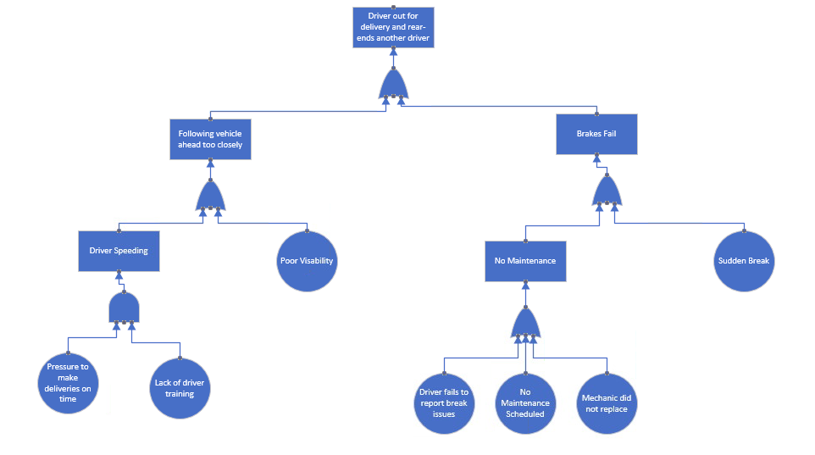

## Barrier Analysis

Hazard-Barrier Matrix

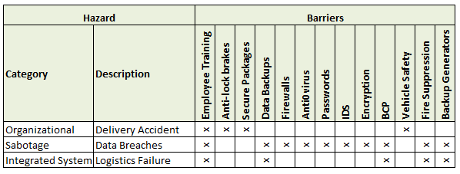

**Safety Barrier Diagram**

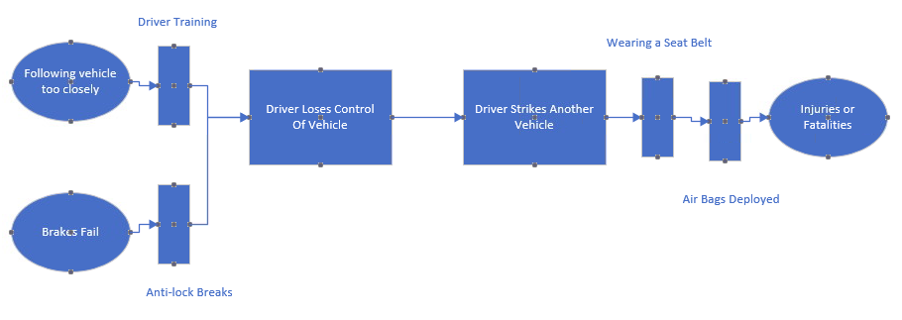

## Cause-Consequence Analysis

Delivery vehicles are equipped with many safety features to assist the driver in avoiding accidents and serious injury like anti-lock brakes, airbags, and seat belts. While the driver should follow driving laws and have driver safety training, accidents by nature can still occur. If any of the proactive and reactive barriers installed on the vehicle fail, the probability of a serious accident increases. Proper functionality of these components impacts both Shipping & Delivery and Fleet Maintenance business functions. The Event Tree Analysis below outlines the probable consequences of mechanical failures of the anti-lock brake system and airbags in the scenario that the driver is following too closely, and the vehicle ahead stops short. Even if the anti-lock brakes do not fail, an accident can still occur where the airbags could deploy on impact. Failure rates have been estimated. The probability that an accident will occur with all these failures has been determined to be .15%.

**Event Tree Analysis- Before New Control**

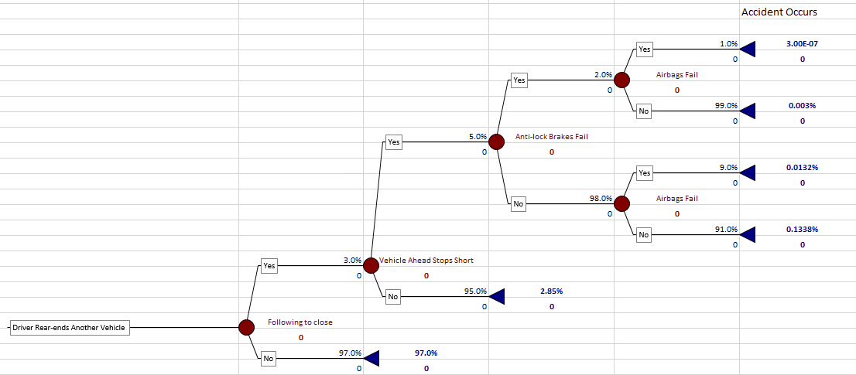

**Personal Safety Issues**

UPS is a people driven business. It cannot function without a safe work environment for its delivery employees; therefore, personal safety is essential to continuing to delivery billions of parcels and packages. Fatalities for delivery drivers (not including heavy duty or tractor trailer drivers) can be calculated using Individual Risk per Annum and Potential Loss of Life. Numbers used from Data Dossier.

Exposure Time Rate α = 41.9 / 168 (hours in a week) = .249 or 24.9%

IRPA = 607 / 51410 * .249 = .0029

PLL = 7870 * .0029 = 23.14 fatalities

Additionally, nonfatal injuries can cause significant time out of work for delivery drivers which can put a strain of productivity. In 2018, U.S. Bureau of Labor Statistics reported the incidence rate of nonfatal occupational injuries and illnesses with time out of work to be 233 cases per 10,000 of light truck or delivery service. For the population of drivers for U.S. (7870) this equates to 183.4 incidences. While it does not consider severity or number of days out of work, it could be a significant cost that can be mitigated by adding vehicle safety controls.

**Event Tree- After New Control**

Based on our analysis, we would recommend an automatic braking feature be installed to avoid the delivery vehicle striking a vehicle ahead if it is following too close. The probability that an accident will occur if the new control fails is dramatically reduced to .0015%.

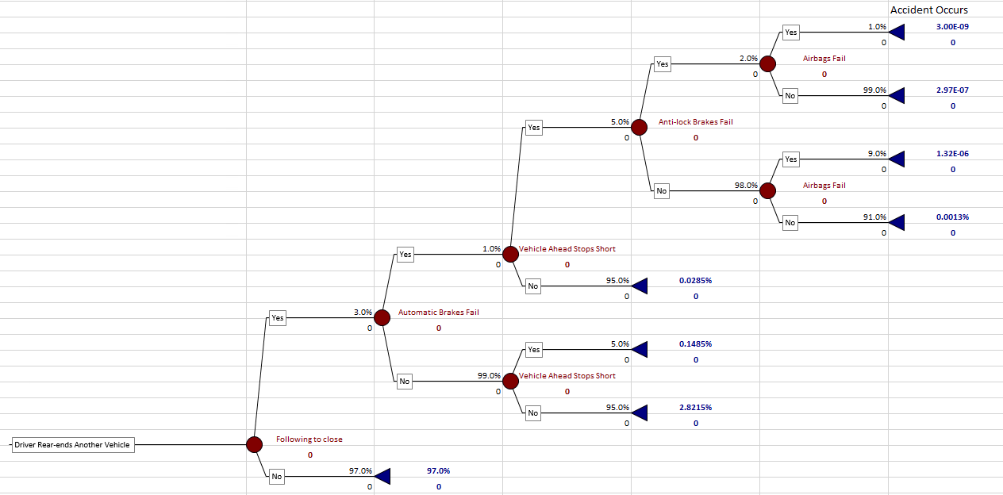

The ALARP Principle strives for risk to be “as low as reasonably practicable”. In the case of driver accidents and injuries, they should never be in the unacceptable region. Additional safety controls for the delivery fleet would lower the risk and keep it in the ALARP Region. Adding automatic breaking features to the delivery fleet is cost that could reduce injuries, save lives, and let UPS remain the industry leader in delivery services.

## References

*Board of Directors.* (n.d.) UPS Investors. Retrieved from [**http://www.investors.ups.com/governance/board-of-directors**](http://www.investors.ups.com/governance/board-of-directors)

Federal Motor Carrier Safety Administration. (2020). UPS Ground Freight INC. Retrieved from

<https://ai.fmcsa.dot.gov/SMS/Carrier/121058/BASIC/UnsafeDriving.aspx>

National Institute of Standards and Technology/U.S. Department of Commerce. (2012). *NIST*

*Special Pubilication 800-30: Guide for Conducting Risk Assessments Revision 1* [PDF]*.*

Gaithersburg, MD. Retrieved from <https://nvlpubs.nist.gov/nistpubs/Legacy/SP/nistspecialpublication800-30r1.pdf>

Rausand, M. & Safari Books Online (Firm). (2011). *Risk assessment: Theory, methods, and applications* (1st ed). Wiley. Retrieved from

<https://learning.oreilly.com/library/view/risk-assessment-theory/9780470637647/13_chapter04.html>

*UPS Fact Sheet.* (n.d.). UPS Pressroom. Retrieved from <https://pressroom.ups.com/pressroom/ContentDetailsViewer.page?ConceptType=FactSheets&id=1426321563187-193>

U.S. Bureau of Labor Statistics. (2020). Industries at a Glance: Truck Transportation NAICS 484. Retrieved from <https://www.bls.gov/iag/tgs/iag484.htm>

U.S. Bureau of Labor Statistics. (2020). Injuries, Illnesses, Fatatlies: Fact Sheet Truck Drivers 2018, July 2020. Retrieved from <https://www.bls.gov/iif/oshwc/cfoi/truck-drivers-2018.htm#_edn5>